Make a Dye-sensitized Name: _______________________

Solar Cell Date: ________________________
Student background information

Directions: Read the articles and answer the questions in preparation for the experiment.

Article #1
How Green Are Those Solar Panels, Really?
As the industry grows, so does concern over the environmental impact.
By Christina Nunez, National Geographic
PUBLISHED NOVEMBER 11, 2014
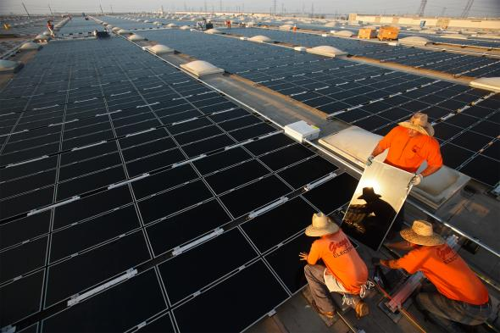
VIEW IMAGES
Workers install solar panels in California. Although solar energy is a clean alternative to fossil fuels, making the panels themselves can have a negative environmental impact.
PHOTOGRAPH BY MICHAEL MELFORD, NATIONAL GEOGRAPHIC CREATIVE
As the world seeks cleaner power, solar energy capacity has increased sixfold in the past five years. Yet manufacturing all those solar panels, a Tuesday report shows, can have environmental downsides.
Fabricating the panels requires caustic chemicals such as sodium hydroxide and hydrofluoric acid, and the process uses water as well as electricity, the production of which emits greenhouse gases. It also creates waste. These problems could undercut solar's ability to fight climate change and reduce environmental toxics.
A new ranking of 37 solar manufacturers, the Solar Scorecard, shows that some companies are doing better than others. Chinese manufacturer Trina scored best, followed by California-based SunPower.
The annual scorecard was created by the Silicon Valley Toxics Coalition (SVTC), a San Francisco-based nonprofit that has tracked the environmental impact of the high-tech industry since 1982. It's the group's fifth scorecard, and it shows that the industry is becoming more—not less—opaque when it comes to the sustainability of its manufacturing practices.
The coalition hopes the scorecard will increase transparency in a burgeoning industry that tends to be more focused on survival and growth than on tackling the dirtier side of an otherwise clean energy source.

Patchy Data on Chemicals, Emissions
The SVTC relies on companies' self-reported data for its scorecard, which looks at such things as emissions, chemical toxicity, water use, and recycling. The coalition says the market share of companies willing or able to share details about their operations is declining. It praises the third- and fourth-ranked companies, Yingli and SolarWorld respectively, for responding to the survey every year and for showing a continued commitment to sustainability.
Name-brand companies on the scorecard represent about 75 percent of the solar panel industry, but more generic players that care less about their environmental impact have been entering the market, said Sheila Davis, the coalition's executive director. Her group is concerned that as these discount competitors gain market share, fewer companies will make sustainability a priority.
Varying regulations and manufacturing practices make it difficult to get standardized data about the environmental footprint of photovoltaic panels. A study released in May by Northwestern University and Argonne National Laboratory found that the carbon footprint of a panel from China is twice that of one from Europe, because China has fewer environmental standards and more coal-fired power plants.
China has already seen a backlash. Panel manufacturer Jinko Solar, for example, has faced protests and legal action since one of its plants, in the eastern province of Zhejiang, was accused of dumping toxic waste into a nearby river.
Solar manufacturers in the United States are subject to both federal and state rules that dictate, for example, how and where they can dispose of toxic wastewater. In Europe recent regulations mandate the reduction and proper disposal of hazardous electronic waste.
Still, researchers say it's difficult to get quality data across solar panel markets. The numbers available on the environmental impact of solar panel manufacturing in China are "quite different from those in the U.S. or in Europe," said Fengqi You, assistant professor of engineering at Northwestern University and a co-author of the May study. "It is a very complicated problem."
The SVTC hopes that pushing for more transparency now will lead to better practices later. "It's a new industry," said Davis. If companies adopt sustainable practices early on, she said, "then maybe over the next 10 or 15 years-as these panels begin to come down, the first wave of them, and we're beginning to recycle them-the new panels that are on the market are zero waste."

Not Enough to Recycle Yet
Right now, solar panel recycling suffers from a chicken-or-egg problem: There aren't enough places to recycle old solar panels, and there aren't enough defunct solar panels to make recycling them economically attractive.
Ben Santarris, strategic affairs director for SolarWorld, said his company has made efforts to recycle panels, but the volume isn't there yet. "We have product that's still performing to standard from 1978, so we don't have a big stream," he said. "It is a problem, because on one hand there is an interest in getting ahead of a swelling stream of returning panels. On the other hand, there's not a big market for it right now."
Recycling is particularly important because of the materials used to make panels, said Dustin Mulvaney, an assistant professor of environmental studies at San José State University who serves as a scientific adviser to SVTC. "It would be difficult to find a PV module that does not use at least one rare or precious metal," he said, "because they all have at least silver, tellurium, or indium."
Because recycling is limited, Mulvaney said, those recoverable metals could go to waste: "Companies that are reporting on a quarterly basis, surviving on razor-thin margins—they're not thinking 20, 30 years down the road, where the scarcity issue might actually enter the conversation."
The silicon used to make the vast majority of today's photovoltaic cells is abundant, but a "silicon-based solar cell requires a lot of energy input in its manufacturing process," said Northwestern's You. The source of that energy, which is often coal, he added, determines how large the cell's carbon footprint is.
The SVTC said it's leading an effort to develop a first ever sustainability standard for solar panels, similar to the U.S. Green Building Council's Leadership in Energy and Environmental Design or LEED, within the next two years. That effort will get under way as new solar panel factories come online in the U.S. and elsewhere: Mission Solar just opened a plant in San Antonio, Texas, and SolarCity plans to open a five-billion-dollar factory in western New York.
It remains to be seen whether solar companies will face enough external pressure to drive significant change in a business that, from a power-generation standpoint, already has plenty of environmental credibility.
"Despite the efforts of the SVTC," said Santarris, "there still is not nearly the awareness there should be that solar panels are not all created equal from an environmental standpoint."
But there is optimism that as the industry matures, solar companies will adopt stronger sustainability measures. In just the five years since the SVTC began its scorecard survey, Mulvaney said, it has seen a change.
"When we started this, there was no information on environmental performance, aside from the fact that it saves us from the dirtier fuels," he said. "Now these companies are producing sustainability reports."
On Twitter: Follow Christina Nunez and get more environment and energy coverage at NatGeoGreen.
The story is part of a special series that explores energy issues. For more, visit The Great Energy Challenge.

Christina Nunez is a writer and frequent contributor to National Geographic.

Article #2

How are solar panels currently made?

Solar Manufacturing Process Diagram

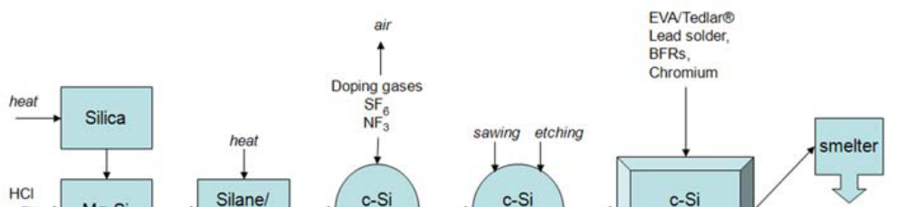
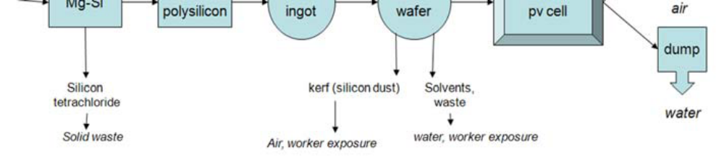

Step 1. Silica is mined and refined into metallurgical grade silicon. This is reacted with hydrochloric acid (HCl) using very high temperatures where silane/polysilicon feedstock and silicon tetrachloride waste is produced.
Step 2. The resulting silane/polysilicon is heated to produce a crystalline silicon (c-Si) ingot that is doped to make c-Si into a semiconductor. The potent greenhouse gases sulfur hexaflouride (SF6) and nitrogen fluoride (NF3) are used in this step to clean the reactors and also in doping (doping adds impurities to a semiconductor to produce or modify its properties).
Step 3. The c-Si ingot is cut into wafers, which are etched with reactive solvents such as hydrofluoric acid to remove surface imperfections.
Step 4. Finally, the wafers are encapsulated with ethyl vinyl acetate (EVA) or Tedlar® to protect the surface, mounted onto a frame, and wired into the PV cell.
Step 5. Without extended producer responsibility, these cells will end up in smelters and dumps where any hazardous materials will cause air and water pollution.

About the chemicals named above:
Silicon (Si) is an element, and is the main component of sand. It is the second-most abundant element found in the earth’s crust. Silicon is considered non-toxic in its elemental form and most of its other forms (silicates). Only after it has been refined and under certain conditions will the form become hazardous.

Silicon tetrachloride (SiCl₄) is a corrosive and is used in silicon-based PV cell production. It reacts with water to form hydrochloric acid and can cause tissue damage. Inhalation of SiCl₄ causes severe respiratory problems, skin contact causes severe pain, and eye contact can cause permanent damage. It is one of a group of chemicals known as chlorosilanes.
Silicon dioxide (SiO₂), or refined crystalline silica (fine powder), is a potent respiratory hazard, irritating skin and eyes on contact. Inhalation causes lung and mucus membrane irritation. Eye irritation results in watering and redness. Lung cancer is associated with occupational exposures to crystalline silica among miners, diatomaceous earth workers, granite workers, pottery workers, brick workers, and others.
Hydrofluoric acid (HCl) is a solution of hydrogen fluoride in water. While it is extremely corrosive and difficult to handle, it is technically a weak acid. The danger in handling hydrofluoric acid is extreme, as skin saturation with the acid in areas of only 25 square inches (160 cm²) may be relatively painless, yet ultimately fatal. High concentrations of hydrofluoric acid and hydrogen fluoride gas will also quickly destroy the corneas of the eyes.
Nitrogen trifluoride (NF₃) is used to clean reactors and to dope polysilicon semiconductors. It emits toxic fumes when burned or reacted, and can cause asphyxiation. The IPCC considers NF₃ a significant greenhouse gas, making fugitive emission control very important.
Polysilicon is the most widely used solar PV semiconductor. It is obtained by heating silane or trichlorosilane gas to 1500˚C.
Sulfur hexafluoride (SF₆) is used to etch and dope semiconductors and to clean reactors in PV manufacturing. It is relatively inert and is considered an asphyxiant. The IPCC considers SF₆ the most potent greenhouse gas known.
Ethyl vinyl acetate (EVA) is used to encapsulate solar PV cells. It is a non-toxic alternative to soft plastics like polyvinyl chloride (PVC), but may release volatile organic compounds (VOCs) during manufacture.
Information for this handout was taken from The Silicon Valley Toxics Coalition Report: “Toward a Just and Sustainable Solar Energy Industry.”
Article #3
What is Green Chemistry?
Green chemistry is the design of chemical products and processes that reduce and/or eliminate the use or generation of hazardous substances. This approach requires an open and interdisciplinary view of material and product design, applying the principle that it is better to consider waste and hazard prevention options during the design and development phase, rather than disposing, treating and handling waste and hazardous chemicals after a process or material has been developed.
Green chemistry is an opportunity for introducing innovative solutions to chemical problems and applying sustainability towards molecular design. Chemists have the ability to design products and processes that have reduced impacts on humans and the environment and therefore creating sustainable chemical building blocks for materials and products in our society.
Green chemistry products that are successful in the marketplace must accomplish three things:
- It must be more environmentally benign than an existing alternative
- It must be more economically viable than an existing alternative
- It must be functionally equivalent to or outperform existing alternatives
There are 12 principles of green chemistry:
- Waste Prevention: It is better to prevent waste than to treat and clean up waste after it is formed.
- Atom Economy: It is better to prevent waste than to treat and clean up waste after it is formed.
- Less Hazardous Chemical Synthesis: Whenever practicable, synthetic methodologies should be designed to use and generate substances that possess little or no toxicity to human health and the environment.
- Designing Safer Chemicals: Chemical products should be designed to preserve efficacy of the function while reducing toxicity.
- Safer Solvents and Auxiliaries: The use of auxiliary substances (solvents, separations agents, etc.) should be made unnecessary whenever possible and, when used, innocuous.
- Design for Energy Efficiency: Energy requirements should be recognized for their environmental and economic impacts and should be minimized. Synthetic methods should be conducted to ambient temperature and pressure.
- Use of Renewable Feedstocks: A raw material or feedstock should be renewable rather than depleting whenever technically and economically practical.
- Reduce Derivatives: Unnecessary derivatization (blocking group, protection/deprotection, temporary modification of physical/chemical processes) should be avoided whenever possible.
- Catalysis: Catalytic reagents (as selective as possible) are superior to stoichiometric reagents.
- Design for Degradation: Chemical products should be designed so that at the end of their function they do not persist in the environment and instead breakdown into innocuous degradation products.
- Real-time Pollution Prevention: Analytical methodologies need to be further developed to allow for real-time in-process monitoring and control prior to the formation of hazardous substances.
- Safer Chemistry for Accident Prevention: Substance and the form of a substance used in a chemical process should be chosen so as to minimize the potential for chemical accidents, including releases, explosions and fires.
Learn more about Green Chemistry at https://www.beyondbenign.org/about-green-chemistry/
Pre-Experiment Questions
Evaluate Solar Panel Technology against the 12 Principles of Green Chemistry
Using Article #2 above (“How Are Solar Panels Currently Made?”), evaluate each step against the twelve principles of green chemistry. Record the principles you identify as ones that chemists need to find an alternative for, and why.

Step 1:

Step 2:

Step 3:

Step 4:

Step 5:

