Make a Dye-sensitized Name: _______________________

Solar Cell Date: ________________________
Student lab worksheet

Directions: Follow the steps to do the lab, record all data, and answer the questions.

Materials
- 1 transparent indium tin oxide (ITO) coated glass slide (referred to as ITO slide)
- 1 TiO₂-coated indium tin oxide glass slide (referred to as TiO₂ slide)
- Iodide electrolyte solution (0.5 M potassium iodide mixed with 0.05 M iodine in propylene glycol)
- 2 small binder clips
- 1 blackberry
- 1 spatula
- 1 pencil
- 1 piece of parafilm, cut to 20 mm x 40 mm size
- 1 small aluminum pan (or other small dish)
- 1 paper towel
- 1 razor blade/scalpel/precision utility knife knife (unless the teacher will solely handle it)
- Multimeter (set to measure voltage)

Note: Handle the glass plates by the edges to avoid touching the faces of the plates

Lab Procedure
- Place the blackberry in the aluminum pan.
- Using a spatula, crush the blackberry to extract the juices. Scoop out the solid pulp.
- Remove the glass slide containing the white TiO₂ coating from its bag. Handle the glass slide by the edges only. Determine which side has the TiO₂ coating.
- Place the glass slide with the TiO₂ face down into the aluminum pan. Allow to sit for 3-5 minutes.
- Remove the ITO-coated glass slide from its bag. Determine which side the coating is on by using a multimeter with its setting placed on resistance (Ω). The indium tin oxide coating is on the side of the slide that gives a non-zero reading on the multimeter.
- Using the tip of a graphite pencil, lay down the carbon catalyst by shading the indium tin oxide coated side of the slide. The graphite may not leave a visible mark.
- Remove the TiO₂ slide from the blackberry juice. Use the paper towel to gently blot the excess juices off the slide. Dry the slide as much as possible, but do not remove any of the TiO₂ coating. Do not wipe the slide, as this may remove some of the TiO₂ coating.
- Remove and discard the wax paper backing from the parafilm and place the parafilm on top of the dye-coated TiO₂ slide. Use the eraser end of the pencil to press the parafilm to the glass slide in the area that borders the TiO₂
- READ ENTIRE STEP CAREFULLY BEFORE BEGINNING: Using a razor blade, carefully cut out the area of the parafilm that sits on top of the TiO₂. Press lightly with the blade, so that the conductive coating does not scratch off. Reinforce the parafilm seal around the edges of the TiO₂ area with the eraser end of the pencil.

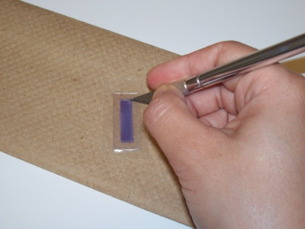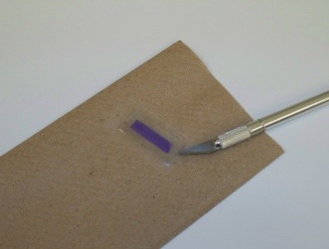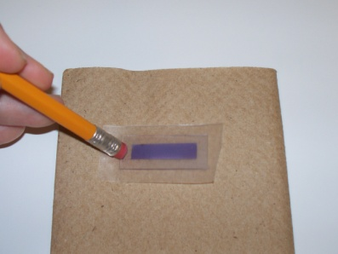

- Place 1-2 drops of the iodide electrolyte solution on top of the TiO₂. The parafilm should act as a wall that prevents the electrolyte solution from leaking out.
- Place the ITO-coated glass slide on top of the TiO₂ slide so that the conductive sides face each other. Stagger the slides to expose as much of the glass slide as possible and to cover the entire TiO₂.

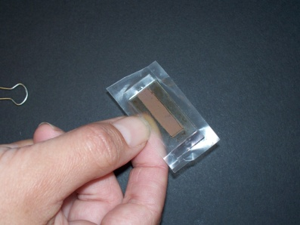

- Use the 2 small binder clips to hold the slides together along the longer sides.
- Carefully push back a small amount of the parafilm wall to expose a tiny part of the conductive side of the slide.
- Place the multimeter probes on opposite ends of the solar cell’s conductive glass slides.

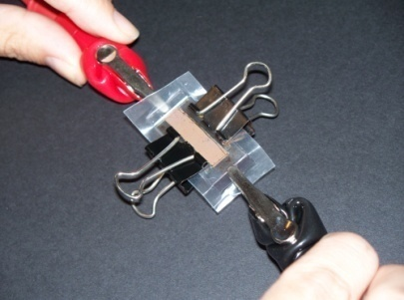

- Place the solar cell under either sunlight or a flashlight.
- With the multimeter set to measure electric potential, measure the voltage of the solar cell.
- Record on the data table how many millivolts (mV) are generated for the light source.
- Repeat steps 15–17 for 1 or 2 more light sources (see your teacher to clarify how many light sources you will need to collect data for).
- Sum up how many volts the class would make as a whole if the cells were connected in a series.
- Clean the workspace according to your teacher’s waste disposal instructions.

Class Data Table
Group | Voltage from light source 1 (mV) | Voltage from light source 2 (mV) | Voltage from light source 3 (mV) | Observations/notes
AVERAGES

Post-Lab Questions:
- Which light source had the highest average millivolt reading? Why do you think it generated the highest millivolt numbers?

- Which light source had the lowest average millivolt reading? Why do you think it generated the lowest millivolt numbers?

- How precise are the millivolt readings for each light source? Teachers can set their own standards for what precise measurements mean in their class.

- What are 3–5 variables that contributed to the variation in millivolts produced within and/or between groups?

- If you could re-do this lab, what are two things you would do differently, and why?

- What was your biggest learning moment in this lab?

- Solar Cell Technology Comparison: Using the 12 principles of green chemistry, chart the production differences between traditional solar cells and dye-sensitized solar cells. Refer to handouts and your lab to complete the grid. Remember: green chemistry is a growing, evolving, and dynamic field; use the last column to highlight areas where the solar cell production process can still be improved.

Principle | Traditional solar cell production | Dye-sensitized solar cell production | Areas of improvement
#1
Pollution prevention

#2
Atom economy

#3
Less hazardous synthesis

#4
Design safer chemicals

#5
Safer solvents and auxiliaries

#6
Energy efficiency

#7 Renewable feedstocks

#8
Reduce derivatives

#9
Catalysis

#10
Design for degradation

#11
Real-time analysis

#12
Accident prevention

